DATE: 13.12.2019
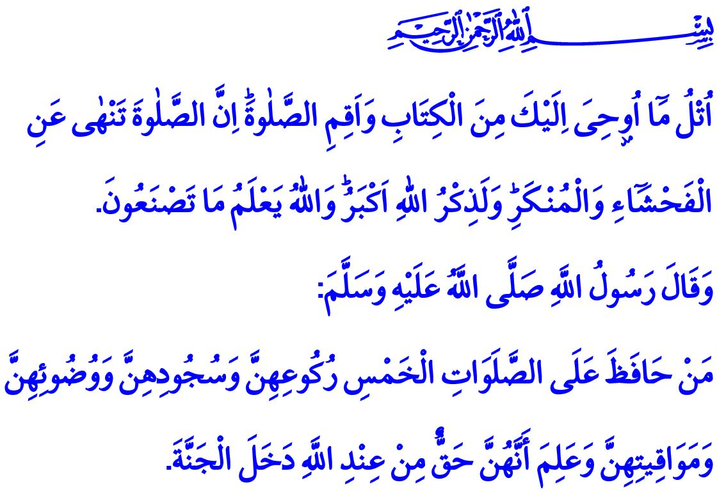
SALAH: OUR STRUGGLE TO GETTING CLOSER TO ALLAH
Honorable Muslims!
One day the Prophet Muhammad (saw) was having a conversation with his companions and asked them, "If there was a river at the door of any of you and he took a bath in it five times a day, would you notice any dirt on him?" His companions replied, "Not a trace of dirt would be left." Thereupon said the Prophet Muhammad (saw), "That is the example of the five prayers with which Allah annuls sins."
Dear Believers!
The most deeply-rooted form of worship in the history of prophets, salah is one of the five pillars of our exalted religion Islam. It is the symbol of turning towards Allah (swt) with the soul, body, mind, heart, love, respect, and the entire being in short. We as humans can attain true peace if we, acceptantly and in a heartfelt manner, respond to Allah's (swt) invitation to servitude and perform the worship of salah. But when we neglect our salah, thereby causing the connection between Him and us to weaken, then we fall captive to our worldly desires, thereby becoming frustrated.
Dear Muslims!
Standing in awe of Allah (swt) for salah upon the lofty call of the adhan, Muslims submit their love, devotion, obedience, and submission to Him. Salah, in this sense, is the moment for Muslims looking forward to meet Him in the closest manner. It is a holy journey Muslims set out on, leaving behind all the worldly rush, problems, and troubles. It is the desire, of people who have fallen far away from the true homeland of heaven, to return to Him after living a sincere life without going astray from the true path. In this respect says the Prophet Muhammad (saw), "The key to Paradise is salah."
Salah is the time to give thanks and express gratitude to Allah (swt). It is the duty of loyalty for Muslims towards Him, Who creates, allows to live, feeds with blessings, protects, and forgives.
Dear Believers!
In the verse I have recited at the beginning of the khutbah, the Almighty Allah (swt) states, "Recite, o
Muhammad, what has been revealed to you of the Book and establish prayer. Indeed, prayer prohibits immorality and wrongdoing, and the remembrance of Allah is greater. And Allah knows that which you do." Salah, then, is the struggle to get purified and protected. A Muslim conscious and aware of worship is one who values and pays great attention to salah, fulfilling all its requirements duly and in awe, from takbir recited at the beginning to the salam at the end. The awareness of worship is about the awareness of being a servant to Allah (swt). It is to live piously, mercifully, and kindly with the awareness that Allah (swt) always oversees and hears.
This is why salah does not only represent the debt of worship for Muslims, but also their superior morals. People who perform salah are protected against any kind of extravagancy, rudeness, and violence. Because of the strengthened spirituality due to salah, they stay away from behaviors that are against the sense of shamefulness and rules of etiquette.
Dear Muslims!
In the Qur'an, all people are addressed in the person of the Prophet Muhammad (saw) as follows, "And enjoin prayer upon your family and people and be steadfast therein. We ask you not for provision; We provide for you, and the best outcome is for those of righteousness."As required of this commandment, the Prophet Muhammad (saw) would go to the door of his daughter Fatimah every morning and invite everybody in the house to performing salah, "O Ahl al-Bayt (the members of the Prophet's family)! Come on, to salah!" We are similarly responsible to get ourselves and our families accustomed to performing salah.
Then, let us, with our families, not remain deprived of the chance to meet Allah (swt) in the healing, comforting, and calming climate of salah. Let us not neglect performing salah which is both "the pillar of the religion" in this world and "the question to be asked of us to give account for" in the Hereafter. Let us not forget that salah is not a burden on us but, on the contrary, it is a unique opportunity to get to know and refresh our own self, as well as to get mature through remembering, thanking, and contemplating. I would like to conclude the khutbah with the following good news from the Prophet Muhammad (saw), "Whoever continues to perform five-times daily salah, knowing that to do so is the commandment of Allah, and showing due diligence to the salah's ruku', sajdah, wudu', and hour, goes to heaven."

Bukhari, Mawaqit al-Salat, 6.
Tirmidhi, Taharah, 1.
Ankabut, 29/45.
Ta-Ha, 20/132.
Tirmidhi, Tafsir al-Qur'an, 33.
Ibn Hanbal, IV, 266. General Directorate of Religious Services

